**SUPERVISORY MEETING**

**~ BRIEFING NOTES ~**

28th January 2015

Supervisors: Prof. Liz Bacon

Prof. Lachlan MacKinnon

Dr. Cos Ierotheou

Contents

Introduction 1

1. After some though about what was said in the last meeting, it became apparent that the three sieves of proof approach had inconsistencies. 2

2. I was having difficulty adding more theories to the web site because each had to be entered in several different places. 4

3. The logic behind the structure of the site was starting to break down because it was obvious that topics of interest were emerging rather than the overview as at present. 5

4. Trying to write papers highlighted the difficulty keeping track of the literature. I needed something that fitted my needs better. 6

5. Sitting behind problems 2 to 4 above was the fact that a plan was needed for where I was to go. The plan would have to be easily amendable as ideas changed. 7

Creating templates for papers and the PhD 7

Creating the structure for the PhD 7

Thinking about how the ideas could be tested 8

Conclusion 10

# Introduction

The Christmas break gave me the chance to take a deep breath and look at what had been produced so far. The meeting in November triggered several areas of thought.

The main problems identified were:-

1. After some thought about what was said in the last meeting, it became apparent that the three sieves of proof approach had inconsistencies.
2. I was having difficulty adding more theories to the PhD tracking web site because each had to be entered in several different places.
3. The logic behind the structure of this site was starting to break down because it was obvious that topics of interest were emerging rather than the overview as at present.
4. Trying to write papers highlighted the difficulty keeping track of the literature. I needed something that fitted my needs better.
5. Sitting behind problems 2 to 4 above was the fact that a plan was needed for the PhD. The plan would have to be easily amendable as ideas changed.

Each of these will be discussed in greater detail below.

However, before getting on to those, it might be worth pointing out that I seem to work differently at this stage to the way you seem to operate. You seem to have the ability to assimilate a large quantity of information and then form ideas/theories based on those.

Not having the capacity of you nice people, I have to go the other way. I have to gather a relatively small set of information and then refine my ideas/theories as I add new information to my repertoire. This way, I need only keep one concept and a small number of extra nuggets – which are used to change the ideas/theories. My expectation is (and always has been) that anything produced WILL alter as new information is uncovered. So, please do not take anything presented here as fixed. Any “arguing” on my part is merely an attempt to clarify things in my mind that may be obvious in yours. Everything presented here is negotiable (as it should be – why have the A-Team and then tell them how to complete a PhD).

# After some though about what was said in the last meeting, it became apparent that the three sieves of proof approach had inconsistencies.

The main problems were:-

1. Cos brought up the issue of induction. Was one negative a proof that the axiom was invalid? For example, I might have a theory that those born in Balham[1] are intellectually inferior to those born elsewhere. My proof is the sample of PhD supervisors (which may be small, but is highly significant – to me anyway) and their charge. Should this, admittedly odd, theory be allowed to invalidate an axiom?
2. The third sieve of proof, the studies on which the axiomata were based, was carried out in the work of John Hattie.
3. There may not be consistency between the groupings Hattie produced and educational theories.
4. The sieves put the cart before the horse. Surely the axiomata should come from the literature rather than the literature being used to support them.

**An interim solution**

Could this be a feedback loop (the Cycle of Virtuous Education?) as in the diagram below?

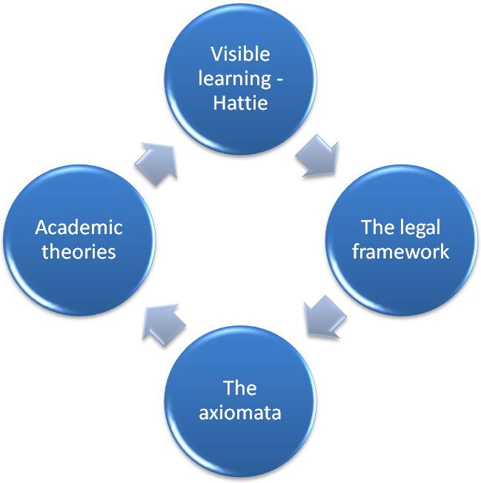

Whilst I’m not sure that the legal framework is appropriate here, the concept is that each area is used to validate the other areas. For example, one might assume that one or more axiomata are missing, in which case the academic theories, the work of Hattie or the legal framework will show that up. Another possibility would be that the list of theories is incomplete (either through my omission or because the academic world has not caught up with it yet) in which case its invisibility would be highlighted by the other areas.

Using this approach has produced two interesting results. First, it was quite surprising how much literature there was complaining about current educational practices. There have been a large number of writers who feel that creativity is being ignored. Also, there has always been a political debate around educational performance (both in terms of quantity and quality). However, it may be my lack of depth in the area, but it seems there is nothing in the literature on identifying these two approaches to education, the idealistic[2] and the authoritarian[3].

Second, I had left out an axiom which covered the zone of proximal development concept. Therefore, another candidate axiom has to be added:-

***New Axiom*** *: Capacity to learn is related to previous internalised learning.*

# I was having difficulty adding more theories to the web site because each had to be entered in several different places.

The PhD web site is my surrogate memory bank. It is where the material that seems relevant to my studies is placed and organised. It also allows my friendly and helpful supervisors to see the latest state of play.

Just before Christmas Lachlan and I had one of those really useful chats in the corridor from which lots of new material sprang. The problem then became one of adding all this to the site. Each new theory appears on several web pages and in a different format on each. This means keeping the site consistent is quite a problem.

Another hiccup was that the site needed restructuring (see sections 3 to 5 for more details). This also meant a lot of copying/pasting/amending which is both time consuming and very boring.

**Solution**

It seems it would be much easier to write a program which has all the details needed in a database. The program could then generate the HTML/PHP automatically. The site structure can then be changed quite easily by altering the program.

This has three advantages; the site becomes easier to manage, the data is consistent and my supervisors are more likely to see what they need.

# The logic behind the structure of the site was starting to break down because it was obvious that topics of interest were emerging rather than the overview as at present.

It had been troubling me that Paul de Bra and Peter Brusilovsky work both independently and together. It was also clear that there were other areas where there were several researchers working in the same field … and that set the cogs on motion. This research is not really interested in “who”, but “what”. The real test of the coverage of the axiomata would be whether they cover all areas of research. It is the general themes (see section 5) that need to be examined rather than the individual researchers.

The themes that appear to occur are:-

* Stages of learning - Steiner, Piaget, Bloom, Kolb
* Conditioning - Twitmyer, Pavlov, Skinner
* The zone of proximal development – Vygotsky, Ausbel
* Metacognition - Flavell
* Learning strategies – Pask, Entwistle, Marton and Säljö
* Learning styles - Dunn and Dunn, Honey and Mumford, Myer and Briggs, Felder and Silverman, Fleming, Gregorc, Hermann
* ... and their refutation - Reiner and Willingham
* The nature of intelligence – Gardner, Sternberg
* Experiential learning - Kolb, Bonwell and Eison, Lave and Wenger
* Adaptive hyper-media – Brusilovsky, de Bra
* Connectivism - Downes and Siemens
* Classroom flipping - Salman Khan
* Meta-analysis – Marzano, Hattie

# Trying to write papers highlighted the difficulty keeping track of the literature. I needed something that fitted my needs better.

I am keen to get going on producing academic papers. There are a number of areas it would be nice to explore; the nature of a VLE, idealistic vs. authoritarian education as well as describing learning dissonance.

Writing is not a problem. As you can see from this document, putting things on paper is one of the strategies I use to organise my thinking. The problem was one of keeping the literature organised in such a way that citing a piece of work was made easier.

I have been using Docear, but that has two problems; it has a tendency to corrupt the bibtex file and it does not harvest the references within a paper. The latter point is a problem with other pieces of referencing software, such as Zotero, Biblio and Endnote, too.

On the positive side, Docear comes with a very nice add-in for Word which allows a file of bibtex references to be used when writing a paper.

**Solution**

Write a program which has a library of bibtex references from which new projects, such as papers, can be created. The program will also allow bibtex entries to be categorised so that they are easier to find.

Most of the bibtex entries exist already since only new materials have to be added. That task is made quite easy with Google Scholar (and Docear). Then when I want to write a paper I can select the relevant items which the program collates into the bibtex file ready for the Word add-in. This will eliminate hunting through hundreds of papers to find the ones needed.

# Sitting behind problems 2 to 4 above was the fact that a plan was needed for where I was to go. The plan would have to be easily amendable as ideas changed.

This gets broken down into several areas; creating templates for papers and the PhD, creating the structure for the PhD and thinking about how the ideas could be tested.

## Creating templates for papers and the PhD

I have been told many times that starting the write-up early on will be useful. I have therefore created a Word template[4] based on the layout used by Muesser Nat. The format she used was the one which appealed to me most of the PhD dissertations I have seen. Obviously, the content is not relevant, but having the chapter numbers in the header, etc. appealed to me, so I created the template.

Lachlan suggested that I use the IEEE template when writing a paper. Their template includes all the details and examples about what goes in each section. These details were then stripped out (since they are easily retrieved from IEEE) giving a blank slate[5].

## Creating the structure for the PhD

It then became clear that the dissertation template would have two uses; as a repository for my thinking and as a project outline. I have therefore put together an initial outline[6] which I hope will help me to structure my thoughts.

This uses the educational themes as the basis for the structure of the literature review. There is still some way to go here, but having a structure (even when it needs amending) will help.

## Thinking about how the ideas could be tested

Creating the structure then led me to consider how the list of axiomata could be tested. There is no reason why the education should be delivered in an e-format, although I would like to see if it can.

There are various ways in which learning can be delivered:-

1. in a classroom orally, with written materials or visual aids.
2. in the home or by friends orally, with written materials or visual aids.
3. by using one or more of the e-formats; web-based content and/or social media.
4. using a mixture of all of the above.

The first item is the one that is the default model of education. This is what governments have traditionally provided. The introduction of VLEs has not really changed this because they are being used as a repository for the written materials or the visual aids. This therefore probably falls outside the scope of this study.

The second item is one which causes an educational divide. Numerous authors including Klebanov, 1994; Smith, 1997; Brooks-Gunn, 1997; Davis-Keen, 2005 have documented the relationship between family background and educational achievement. The vicarious learning that happens (or does not happen) here is outside of the scope of this study. The caveat is that good material ought to increase its chance of being passed on.

The third item is the one which introduces a degree of flexibility into the current system. This is where current practice can be augmented (and in some cases replaced) by e-education. The axiomata would define the format and style of the content. The axiomata used at the moment would indicate that there are two linked phases; the presentation of the content[7] (what we currently think of as the VLE) and the presentation of progress (which we currently call the LMS). Both of these systems would have to be linked and continue throughout the academic career of the individual for the system to work.

The effectiveness of the fourth item is subsumed under the previous three.

**References**

Brooks-Gunn, Jeanne, and Greg J. Duncan. "The effects of poverty on children." The future of children (1997): 55-71.

Davis-Kean, Pamela E. "The influence of parent education and family income on child achievement: the indirect role of parental expectations and the home environment." Journal of family psychology 19.2 (2005): 294.

Klebanov, Pamela Kato, Jeanne Brooks-Gunn, and Greg J. Duncan. "Does neighborhood and family poverty affect mothers' parenting, mental health, and social support?." *Journal of Marriage and the Family* (1994): 441-455.

Smith, Judith R., Jeanne Brooks-Gunn, and Pamela K. Klebanov. "Consequences of living in poverty for young children’s cognitive and verbal ability and early school achievement." *Consequences of growing up poor*(1997): 132-189.

# Conclusion

It would be interesting to know your views on the materials presented above. In particular:-

1. Is the feedback loop a valid method for testing the axiomata?
2. Is it alright to spend some time creating the software that would then make my academic life easier?
3. Is the use of educational themes rather than educational theories an acceptable way to go?
4. Is [the proposed structure](http://www.lordwicks.co.uk/phd-TopicPlan.php) for the dissertation and reasonable starting point?
5. Could the axiomata be tested in a rigorous way using the method described above?

Finally, please note that the axiomata do not take a wide view education, i.e. one in which factors outside the presentation of materials is taken into account, for example:-

* The effect of teaching style on learning.
* The effect of social circumstances on learning.
* The effect of making the materials available 24/7.
* The effect of a similar layout for all materials (boredom and 3D environment).

1. Cos, I’m hoping you were not born in Balham!
2. Allowing the individual to create their curriculum and decide how to fulfil it, albeit with guidance.
3. Where the authorities decide the curriculum based on perceived need and the manner in which it is to be acquired.
4. [http://www.lordwicks.co.uk/documents/Dissertation Template.dotx](http://www.lordwicks.co.uk/documents/Dissertation%20Template.dotx)
5. <http://www.lordwicks.co.uk/documents/ieeePaperTemplate.dotx>
6. <http://www.lordwicks.co.uk/phd-TopicPlan.php>
7. [http://www.lordwicks.co.uk/documents\2014-12-10 VLAtoms 1920x1080.png](http://www.lordwicks.co.uk/documents/2014-12-10%20VLAtoms%201920x1080.png)